# **EventPlan Database**

Note: I have used MySQL server and MySQL workbench (client application)

1. **Create Statement**

CREATE TABLE Eventplan

(

Planno varchar(8) not null,

Eventno varchar(8) not null,

Workdate date not null,

Notes varchar(50),

Activity varchar(30) not null,

Empno varchar(8),

CONSTRAINT PlannoPK PRIMARY KEY(PlanNo),

CONSTRAINT EventnoFK FOREIGN KEY(Eventno) REFERENCES Eventrequest(Eventno),

CONSTRAINT EmpnoFK FOREIGN KEY(Empno) REFERENCES Employee(Empno)

);

Output:

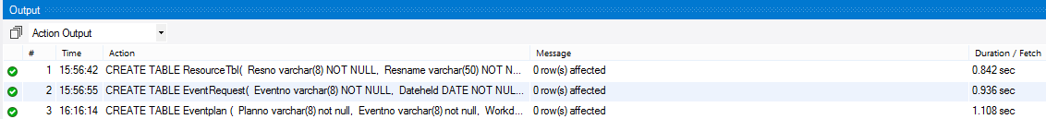

1. **Desc Table**

DESC Eventplan;

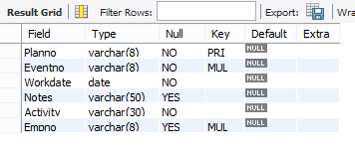

1. **Eventplan Table rows**

SELECT * FROM Eventplan;

